Operating Systems Lab

Lab 8:
System Calls, fork(), exec(), wait(), exit()

Lab Instructor:
Ayesha Akram

System Calls

A Linux System Call is an interface between your program and the kernel. The services required from the kernel, maybe memory managers, and device drivers. System calls are the methods by which users request these services from the kernel.

Common System Calls

There are a lot of system calls, a few of them related to
- Process Management
getpid(), getuid(), getgid(), etc.

- File I/O
create(), open(), close(), etc.

- Process Control
fork(), exec(), wait() etc.

- Signal Handling
kill(), alarm(), etc.

Example of System Call
For example, if we need to write a program code to read data from one file, copy that data into another file. The first information that the program requires is the name of the two files, the input and output files.
In an interactive system, this type of program execution requires some system calls by OS.
- First call is to write a prompting message on the screen
- Second, to read from the keyboard, the characters which define the two files.

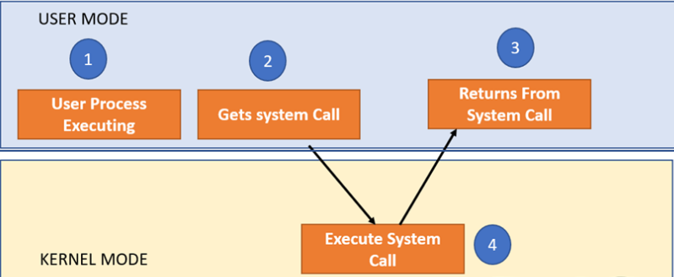

Why do you need System Calls in OS?
Following are situations that need system calls in OS:
- Reading and writing from files demand system calls.
- If a file system wants to create or delete files, system calls are required.
- System calls are used for the creation and management of new processes.
- Network connections need system calls for sending and receiving packets.
- Access to hardware devices like scanner, and printer, need a system call.

Process Identifiers
The basic attributes of a process are its process ID (PID), and its parent process ID (PPID).

The functions that allow a process to obtain its PID and PPID are getpid and getppid. These functions are declared in header file <unistd.h>, and their prototypes are

pid_t getpid(void);
pid_t getppid(void);

The following program prints process, and parent Ids.

Run the following program and save it with the named lab8_e1.c

#include<stdio.h>
#include<unistd.h>
int main(void)
{
printf("The PID of this process (PID)= %d\n", getpid());
printf("The PID of Parent process (PPID)= %d\n", getppid());
return 0;
}

The output of the above program on my computer is the following:

The PID of this process (PID) = 1311

The PID of the Parent process (PPID) =

Unix System Call:
The UNIX system provides several system calls to create and end the program, send and receive software interrupts, allocate memory, and do other useful jobs for a process.
Four system calls are provided for creating a process, ending a process, and waiting for a process to complete. These system calls are fork(), the "exec" family, wait(), and exit().

fork() System Call:

fork() system call is used to create a new process.

- You must use the fork() system call to create a new process. The prototype for the fork() system call is

int fork()

- fork() causes the UNIX system to create a new “child process” process with a new process ID.

If the call to fork() is executed successfully, Unix will make two identical copies of address spaces, Both processes will start their execution at the next statement following the fork() call.

- The procedure is called forking
- An exact copy of the process, memory values, and open resources is produced. The original process that forked, is called the parent, while the newly created, duplicate process is called the child.
- The contents of the child process are identical to the contents of the parent process.
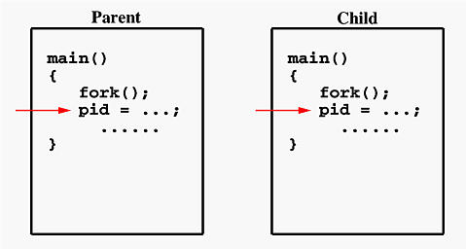

- fork() - Identical copies of address spaces:

Run the following program and save it with the named lab8_e3.c.

#include <unistd.h>
#include <stdio.h>
#include <stdlib.h>

int main(void)
{
fork();
int x=5;
pid_t pid = getpid();
printf("Value of X in PID= %d is %d\n",pid,x);
return 0;
}

Both processes will have their own copy of variable x, initialized to 5. getpid() returns different values in each process because each has a unique PID. Both parent and child process are created with identical copies.

2. fork() - Parent and Child run's parallel:

After fork() statement, both process start execution in parallel(concurrent).

3. fork() - Return Type:

fork() returns twice, once in the parent and once in child, and it returns different
values in the parent and the child. After a call to fork(), the parent's return value is the process id of the newly created child process. The child, however, has a return value of 0. On error, fork(), returns -1.

Run the following program and save it with the named lab8_e4.c

#include <stdio.h>
#include <unistd.h>

int main() {
int pid = fork();

if (pid == 0) {
printf("I'm the child! My PID is %d\n", getpid());
} else {
printf("I'm the parent! My PID is %d and my child's PID is %d\n", getpid(), pid);
}

return 0;
}

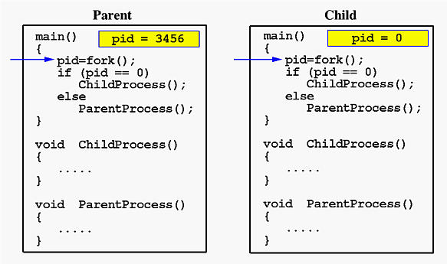

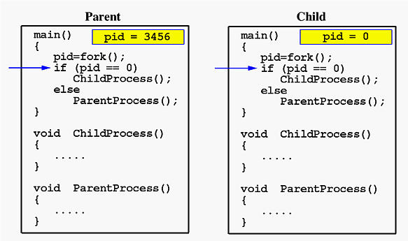
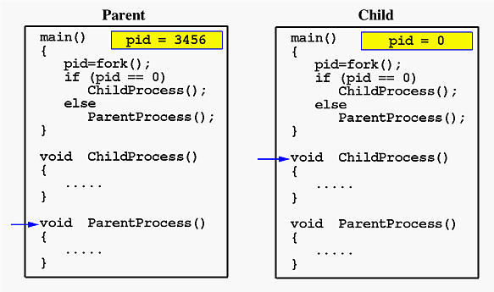

Complete workflow: fork(), exec(), wait(), exit():
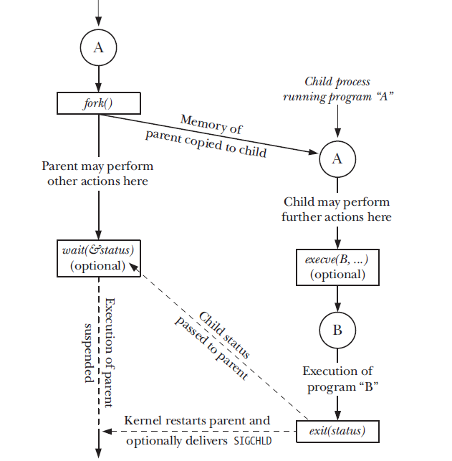

exec() System Call & family:

exec() routines are usually called after a call to fork().Use exec() to launch another program. This combination, known as a fork/exec, allows a process to create a child
The UNIX system calls that transform a executable binary file into a process are the "exec" family of system calls.
Forking creates a process but it is not enough to run a new program, to do that the forked child needs to overwrite its own image with the code and data of the new program and mechanism is exec() creation.

This system call runs when an executable file in the context of an already running process that replaces the older executable file. However, the original process identifier remains as a new process is not built, but stack, data, head, data, etc. are replaced by the new process.

Function | Description
execl() | Pass args as a list (arg0, arg1, ..., NULL)
execv() | Pass args as an array (argv[])
execle() | Like execl() but with environment array
execve() | Like execv() but also with environment array
File1: ex1.c

#include <stdio.h>
#include <unistd.h>
#include <stdlib.h>

int main(int argc, char *argv[])
{
printf("PID of ex1.c = %d\n", getpid());

char *args[] = {"Hello", NULL};
execv("./ex2", args);

printf("Back to ex1.c");
return 0;
}

File2: ex2.c

#include <stdio.h>
#include <unistd.h>
#include <stdlib.h>

int main(int argc, char *argv[])
{
printf("We are in ex2.c\n");
printf("PID of ex2.c = %d\n", getpid());
return 0;
}

• ex1.c → starts first, prints its own PID, and then uses execv() to run ex2.c
• ex2.c → replaces ex1.c in memory and becomes the new running program

exit() System Call:

The exit() system call ends a process and returns a value to it parent. The prototype for the exit() system call is:

void exit(status)
int status;

#include<stdio.h>
#include<unistd.h>
#include<stdlib.h>

int main(void)
{
printf("The PID of this process (PID)= %d\n", getpid());
exit();
printf("The PID of Parent process (PPID)= %d\n", getppid());
return 0;
}
where status is an integer between 0 and 255. This number is returned to the parent via wait() as the exit status of the process.

By convention, when a process exits with a status of zero that means it didn't encounter any problems; when a process exit with a non-zero status that means it did have problems. exit() is actually not a system routine; it is a library routine that call the system routine exit().
exit() cleans up the standard I/O streams before calling exit(), so any output that has been buffered but not yet actually written out is flushed.

wait() System Call:

You can control the execution of child processes by calling wait() in the parent. wait() forces the parent to suspend execution until the child is finished. wait() returns the process ID of a child process that finished.
If the child finishes before the parent gets around to calling wait(), then when wait() is called by the parent, it will return immediately with the child's process ID. (It is possible to have more than one child process by simply calling fork() more than once.). The prototype for the wait() system call is:
int wait(status)
int *status;

where status is a pointer to an integer where the UNIX system stores the value returned by the child process. wait() returns the process ID of the process that ended.

#include <stdio.h>
#include <stdlib.h>
#include <unistd.h>
#include <sys/wait.h>

int main() {
pid_t pid = fork();

if (pid == 0) {
// Child process
printf("Child: I'm working...\n");
sleep(2); // simulate work
printf("Child: I'm done!\n");
exit(0);
} else {
// Parent process
printf("Parent: Waiting for child to finish...\n");
wait(NULL); // wait for the child
printf("Parent: Child has finished. I can continue.\n");
}

return 0;
}

